RTOERO District 15 Halton
Tuesday, February 20, 2024
Oakville Conference Centre
2515 Wyecroft Rd., Oakville, ON L6L 6P8

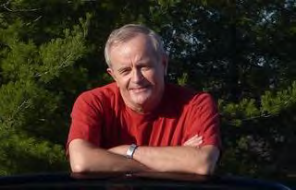
Jim Kenzie, former journalist
for the Toronto Star Wheels Column

STORIES ABOUT CARS!
Exotic, Prosaic, Old, New, and Racing - and
the People who Drive Them!
Essentially, my talk is about the incredible series of lucky breaks that have allowed me to have a career as a journalist that was beyond my wildest dreams. People who are car enthusiasts find that these stories have been their dreams, too! I got to travel all over the world, driving cool cars, from Alfa Romeo to Volkswagen, on great roads like the Autobahns, and race tracks, like the Nurburgring. Now the car landscape is changing; are you ready?

COST: $30.00 for RTO District 15 members/spouses
$35.00 for guests/non-members
Registration: 11:00 am -12:00 noon
Opening Remarks: 12:15 pm
Lunch: 12:30 pm PRESENTATION: 1:30 pm
Cash Bar will be available from 11:00 am.

WINTER SNOWFLAKE LUNCHEON
TUESDAY, FEBRUARY 20, 2024
REGISTRATION (PLEASE PRINT)

Member Name:______________________________

Tel.#: ____________ Email:__________________

Vegetarian Meal ____ Food/Gluten Allergy ___

Spouse/Guest Name:_________________________

Tel #: _____________ Email: __________________

Vegetarian Meal _____ Food/Gluten Allergy____

Request for Accessible Parking: __________

NOTE: Make cheque payable ONLY to
RTOERO District 15
in the amount of :……………….

Please forward registration form & cheque by mail by February 9, 2024
to
Judy Wedeles
4141 Stonebridge Cres. Burlington ON, L7M 4N3
OR
PAY ONLINE at https://district15.rtoero.ca
Home Page – See under Site Map – Click “Pay online for District 15 Event or Activity.”
EMAIL: Special food indications to EventsD15RTO@gmail.com

